**Introduction**

*Grids* are made up of intersecting horizontal and vertical lines. For instance, if you look at a city map, you’ll notice streets crossing paths, forming a clear structure to the city’s layout. This is because a lot of them were designed and built using a grid system.

As a designer, *grid systems* help you organize your designs and provides a series of guidelines to properly align elements on a page. Using this visual layout system can help easily define the space needed between elements, while creating content that guides the user on how to navigate the web page.

Grids can also promote consistency, allowing you to build repeated patterns to carry throughout your designs. Through the use of repetition, the learning curve of using your website can be significantly reduced allowing users to clearly navigate and consume the content.

Let’s explore the different parts of a grid system and discuss how it can help enhance your designs with consistency, alignment, and spacing.

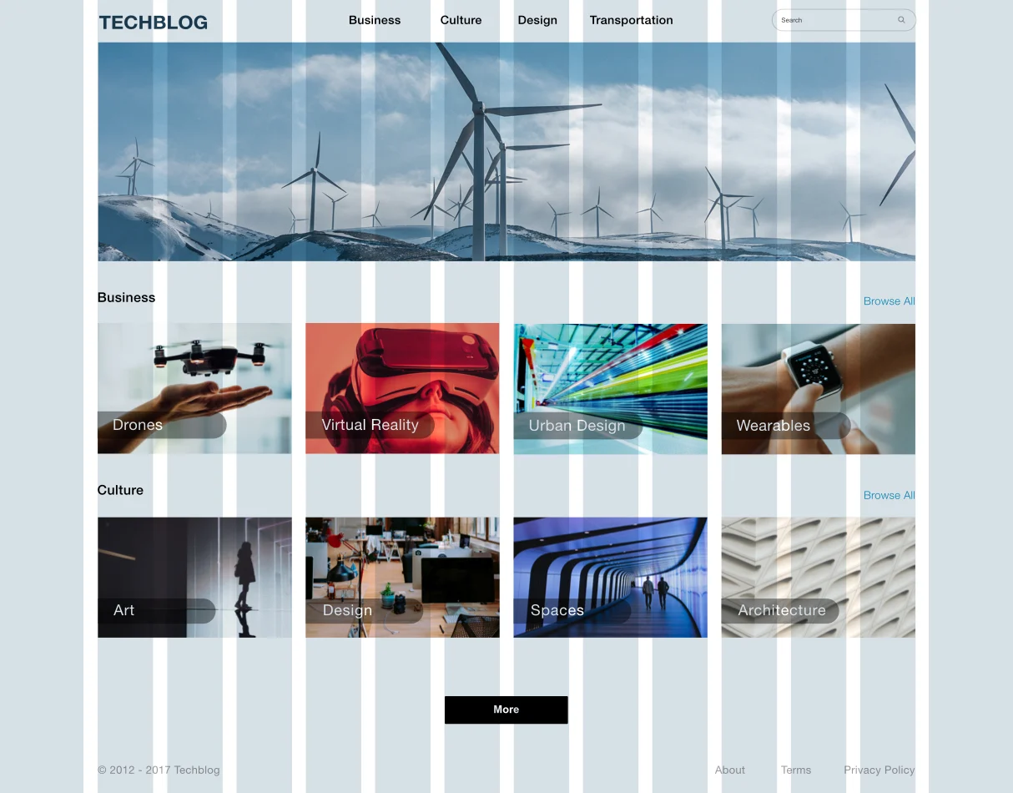

**Grid Types**

Various types of grids exist and are used within all types of visual design. With the creation of the printing press, bookmakers developed a manuscript-style grid, or a *block grid*, to bring structure to text on pages. Within news design, the *column grid* allowed publishers to break the page apart into sections to emphasize different pieces of content.

Similar to news design, the most common type of grid a web designer will use is the column grid. The column grid breaks up a page into vertical units that span the width of the content, and this grid structure can dictate how elements are laid out with precision and elegance.

Let’s continue to explore the anatomy of a grid and what it comprises.

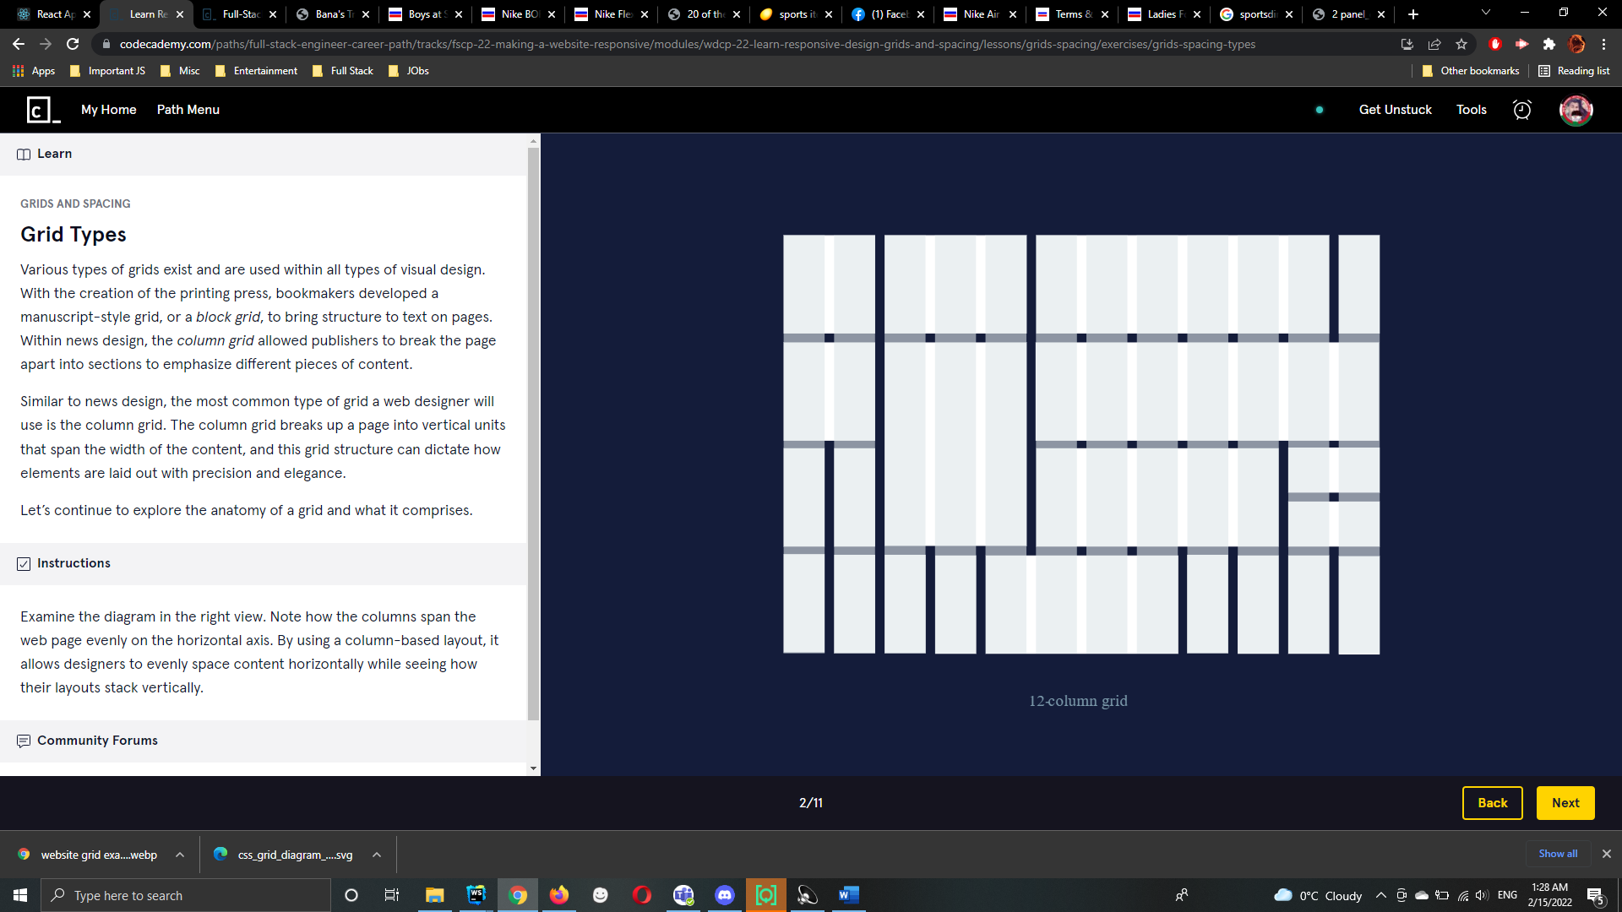

**Grid Anatomy**

When designing a website, the grid comprises three major components: columns, gutters, and margins.

Columns are defined as the vertical sections that span the width of a page. In web design, it’s common to see layouts consisting of 12 or 16 columns, while other may only feature three columns. Defining the number of columns depends on what’s appropriate for your design, device, and or screen viewing size.

Next, a gutter is the negative space between each column. Gutters help in ensuring the columns don’t run together, which would negate the purpose of using a column-based grid.

Margins appear on the left and right sides of the column-based grid. These ensure the content of your designs doesn’t match up to the edges of the browser window.

It’s important to note, margins may vary depending on the width of the grid, browser window, or device. For larger displays, margins may be very noticeable while on smaller screens, they may have the same width as a gutter.

**Instructions**

Examine the diagram to the right. Note the three major components we reviewed in this exercise. Notice how the columns have a gap of space between each column as well as how the grid doesn’t bump up against the side of the web page.

